CSS Assignment

1) What are the benefits of using CSS?

A Cascading Style Sheets is used to format the layout of a webpage.

CSS is easy to maintain due to less maintenance time. this is because a single line code.

Due to faster speed easier maintenance, CSS saves a lot of time and affort in the web

development process due to faster loading time.

You can change the position of an HTML tag with the help of CSS. You can place the element

like an image on any part of the webpage as and when required.

2) What are the disadvantages of CSS?

A Security is important in today’s world driven by technology and data. One of the major

disadvantages of CSS is that it has limited security.

Different browsers work differently. So, you have to check that changes implemented in the

website via CSS codes are reflected properly among all browsers.

Confusion due to many CSS levels.

3) What is deference between CSS2 and CSS3?

A The CSS3 version supports more browsers than CSS2.

CSS3 introduces several new selectors.

* CSS2

CSS2 doesn’t support the border box property.

With CSS2 only web safe font can be used.

CSS splits different section of the code into modules.

There are new way you can write CSS rules with a bunch of CSS selectors.

* CSS3

CSS3 support the border box property.

With CSS3 special font can be used such as those in google font and typecast.

Both CSS and HTML where put into a single file, there was no concept of modules before.

There were no new way to writing the CSS rules.

4) Name a few CSS style components

* Selector: class name, id name or element name that is target
* Attribute: name of the attribute you want to style for example border, color, background, position etc.
* Value of property: value that will be assigned to attribute.

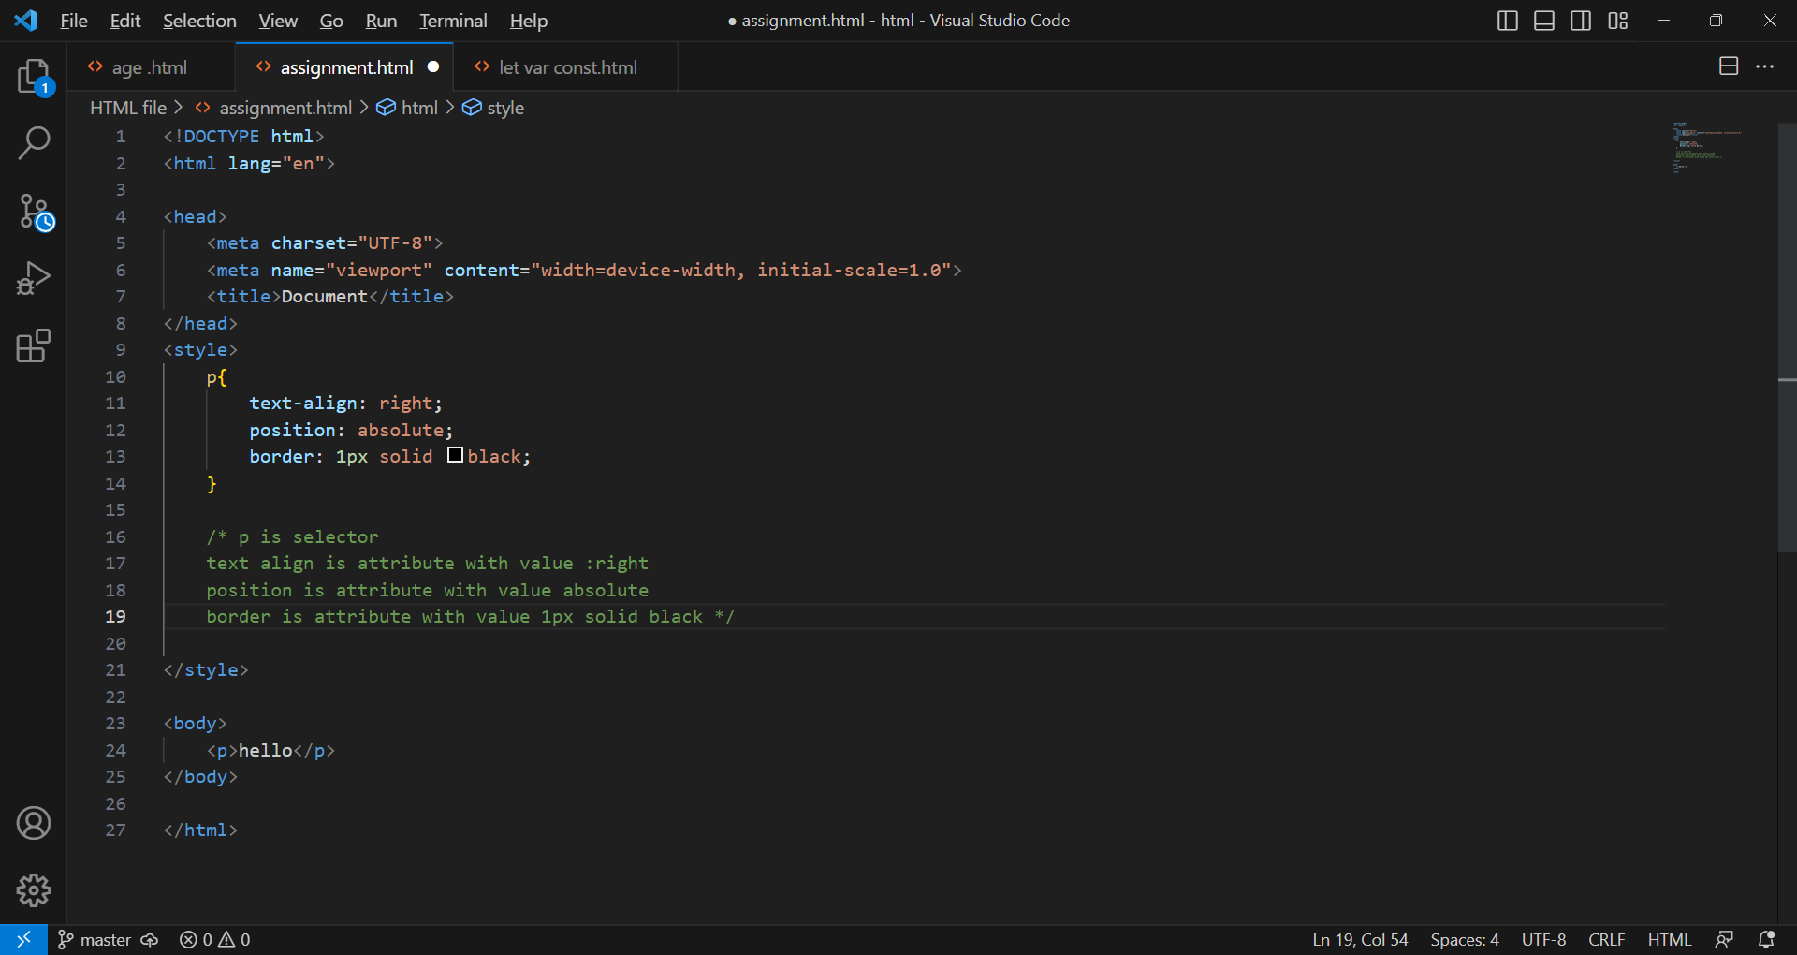

5) What do you understand by CSS opacity?

A The opacity property sets the opacity level for an element.

The opacity level describes the transparency level, where 1 is not transparent at all 0.5 is 50%

Transparent, and 0 is completely transparent.

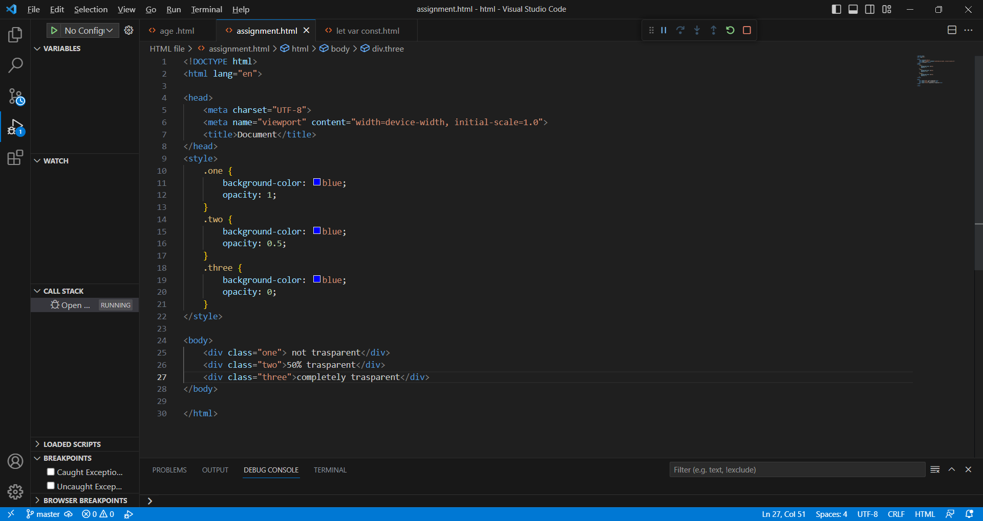

6) How can the background color of an elemant be changed?

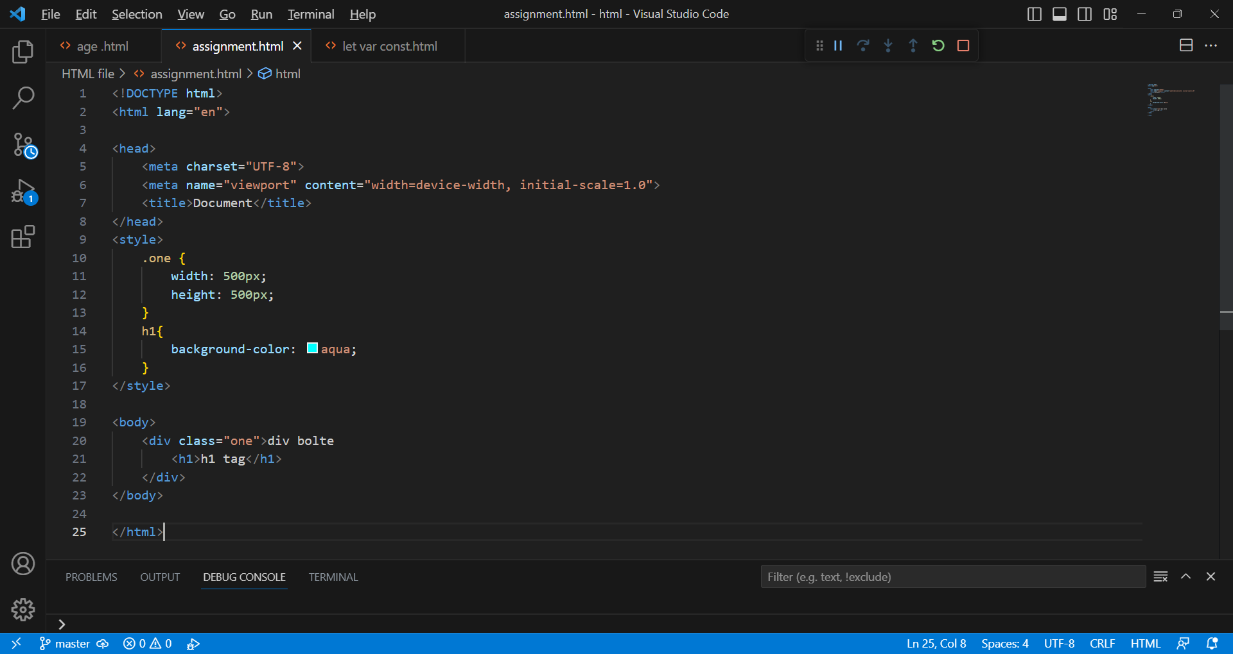

7) how can image repetition of the backup be controlled?

A Using the background repeat property.

The background repeat property in CSS is used to repeat the background image horizontally and

vertically or background image will be repeated or not.

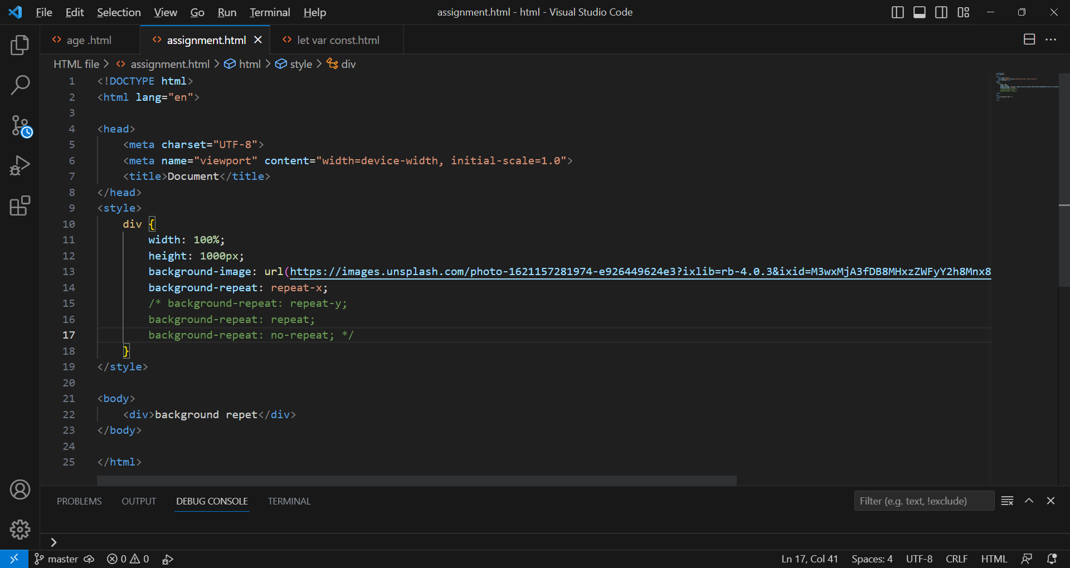

8) What is the use of the background position property?

A The background-position property sets the starting position of a background image.

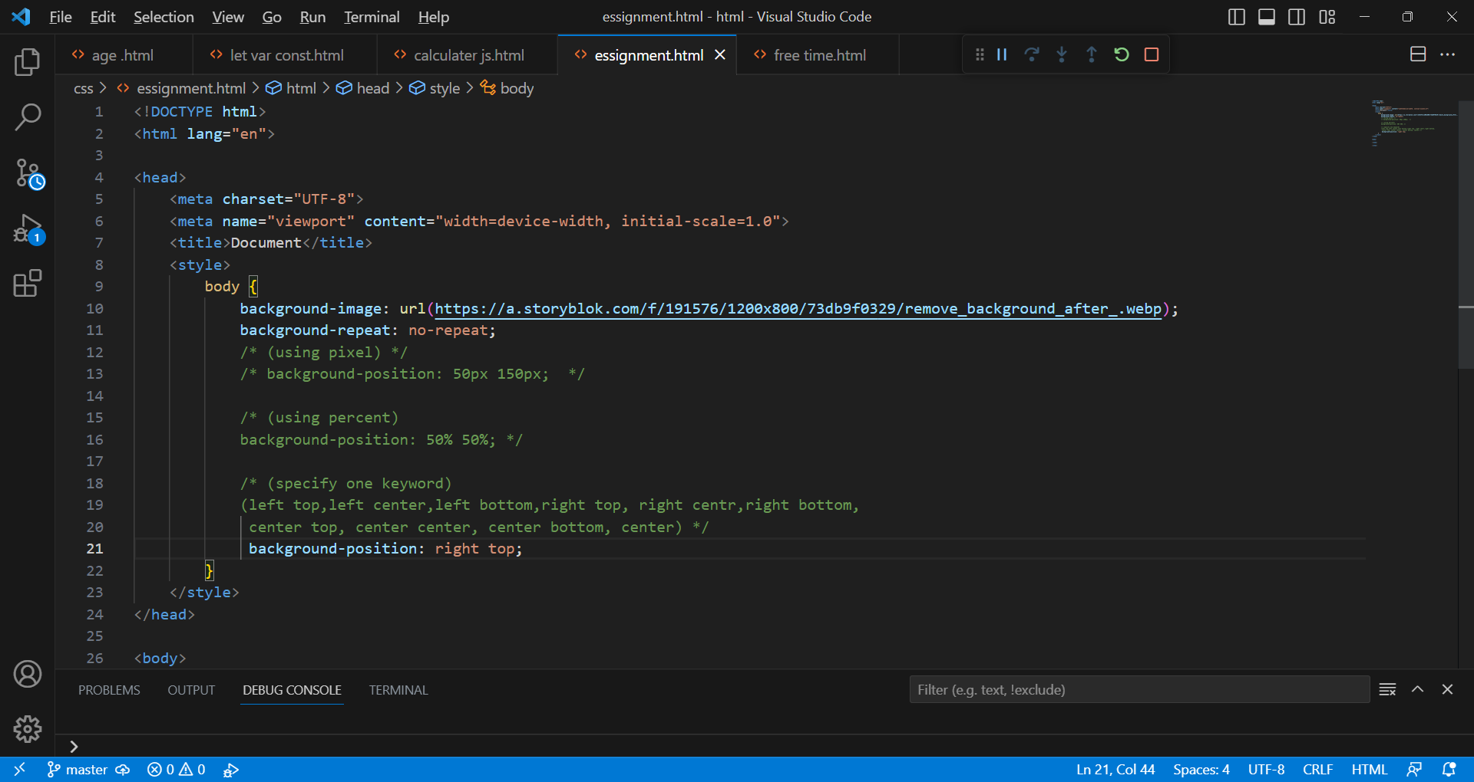

9) Which property controls the image scroll in the background?

A The background- attachment property sets whether a background image scroll with

the rest of the page,or is fixed.

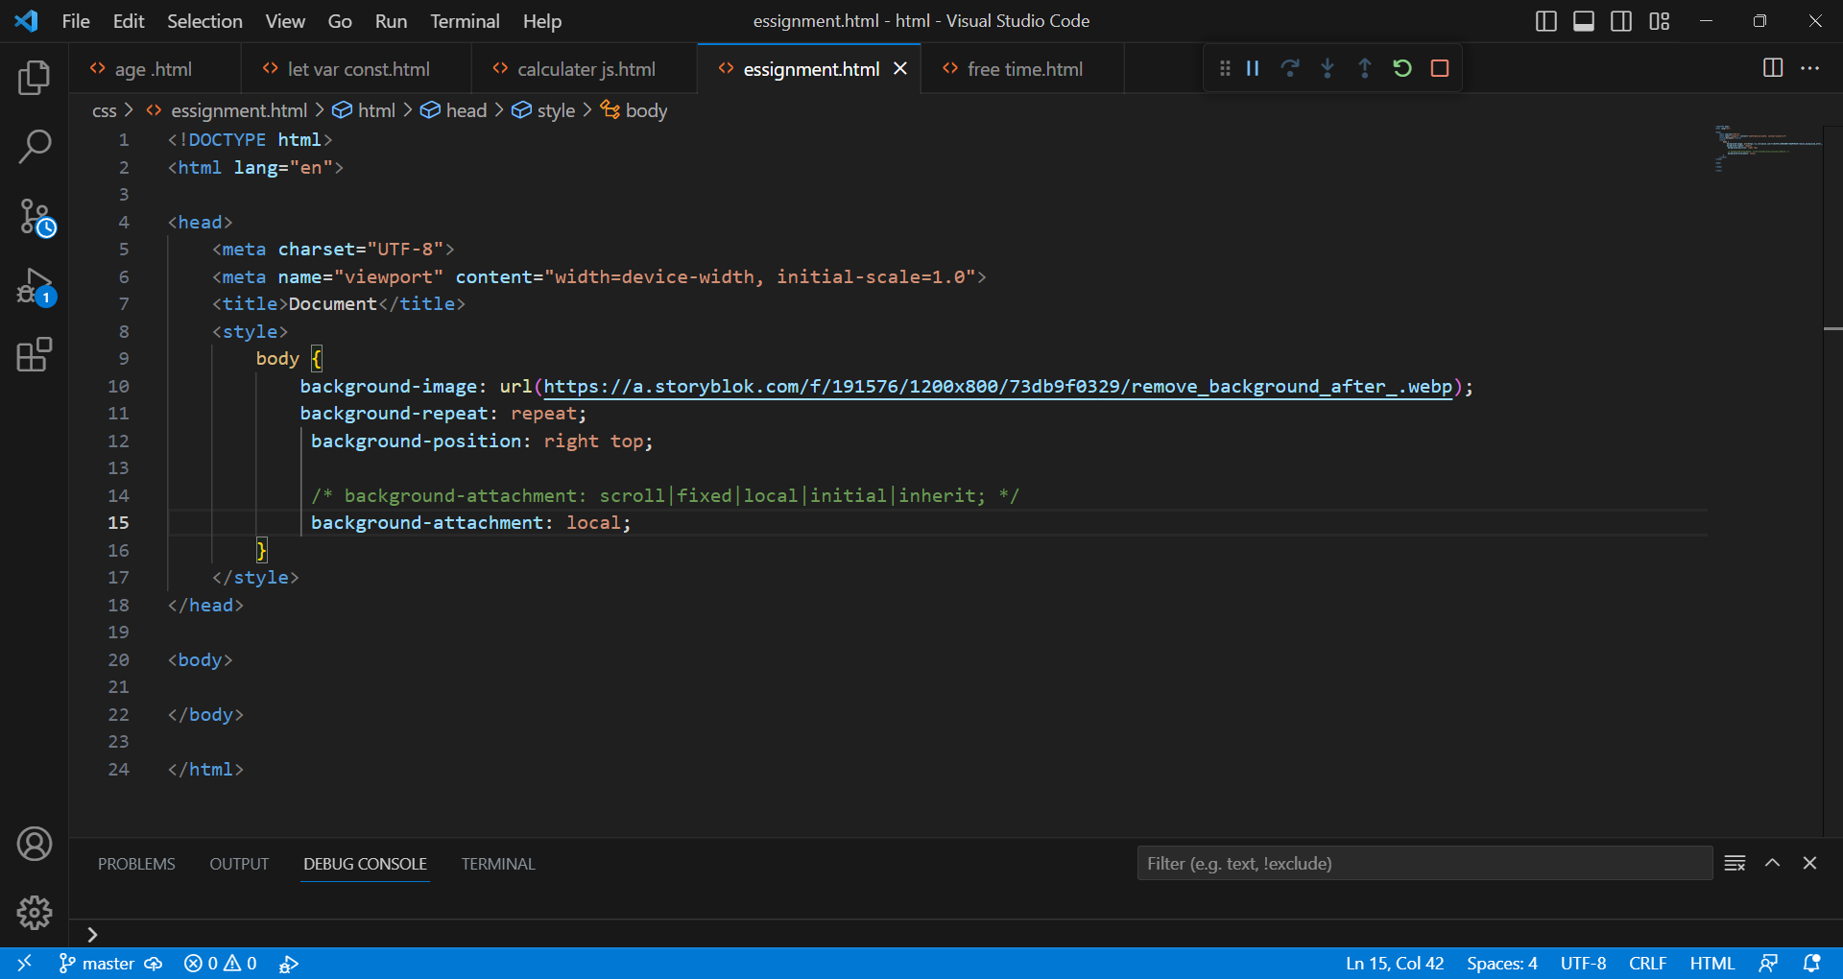

10) Why should background and color be used as separate property?

A It enhances the legibility of style sheets. The background property in CSS, and if it is combined

With color, the complexity will further increase.

11) How to center block elements using css1?

A Define width and set margin auto.

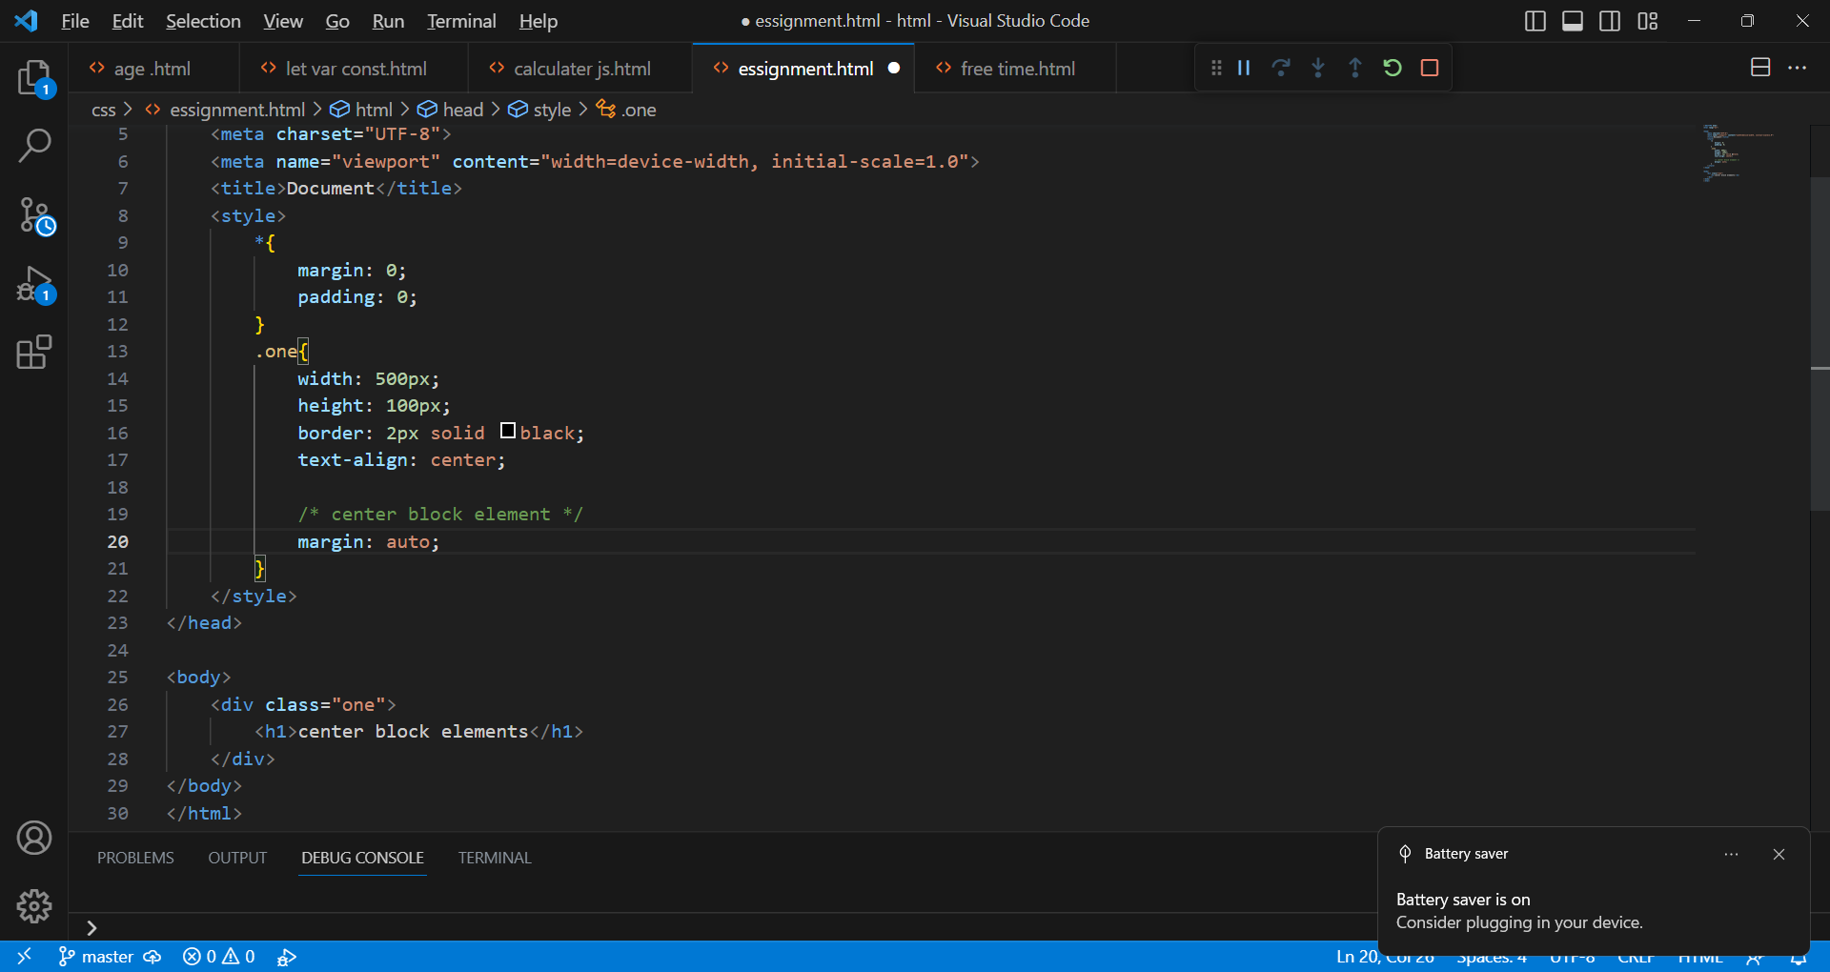

12) How to maintain the CSS specifications?

A The CSS specification are maintained by the world wide web consortium.

13) What are the ways to integrate CSS as a web page?

A . Inline – by using the style attribute inside HTML elemants.

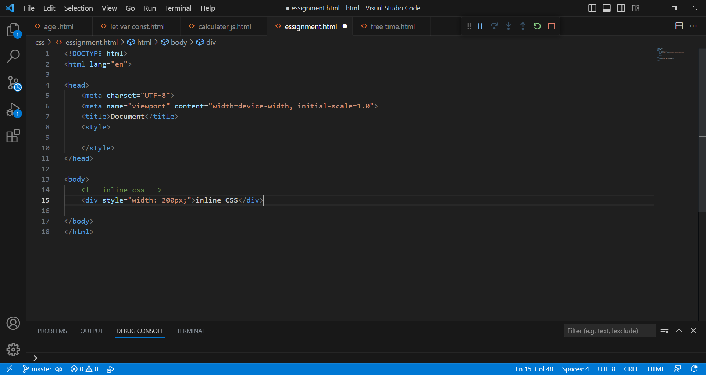

. Internal – by using a <style> elemant in the <head> section.

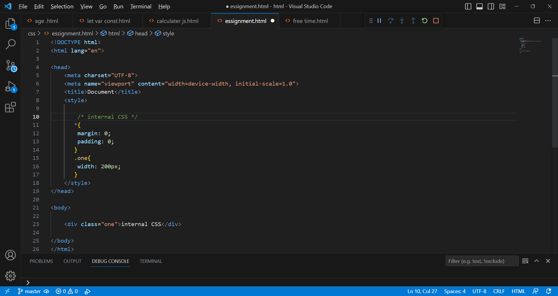

. External – by using a <link> elemant to link to an external CSS file.

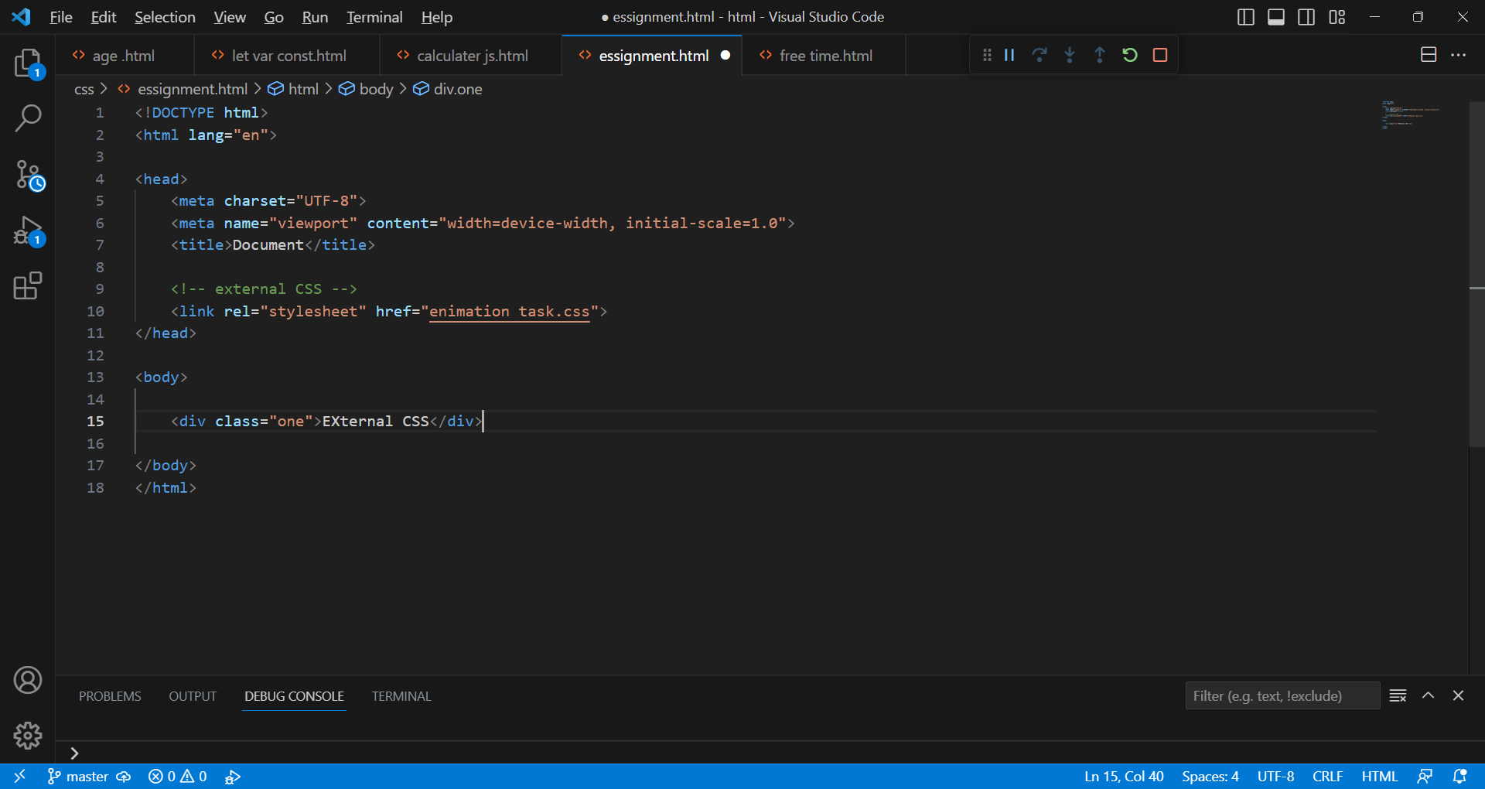

14) What is embedded style sheets?

A Embedded style sheets using a <style> element in a <head> section.one type of internal CSS.

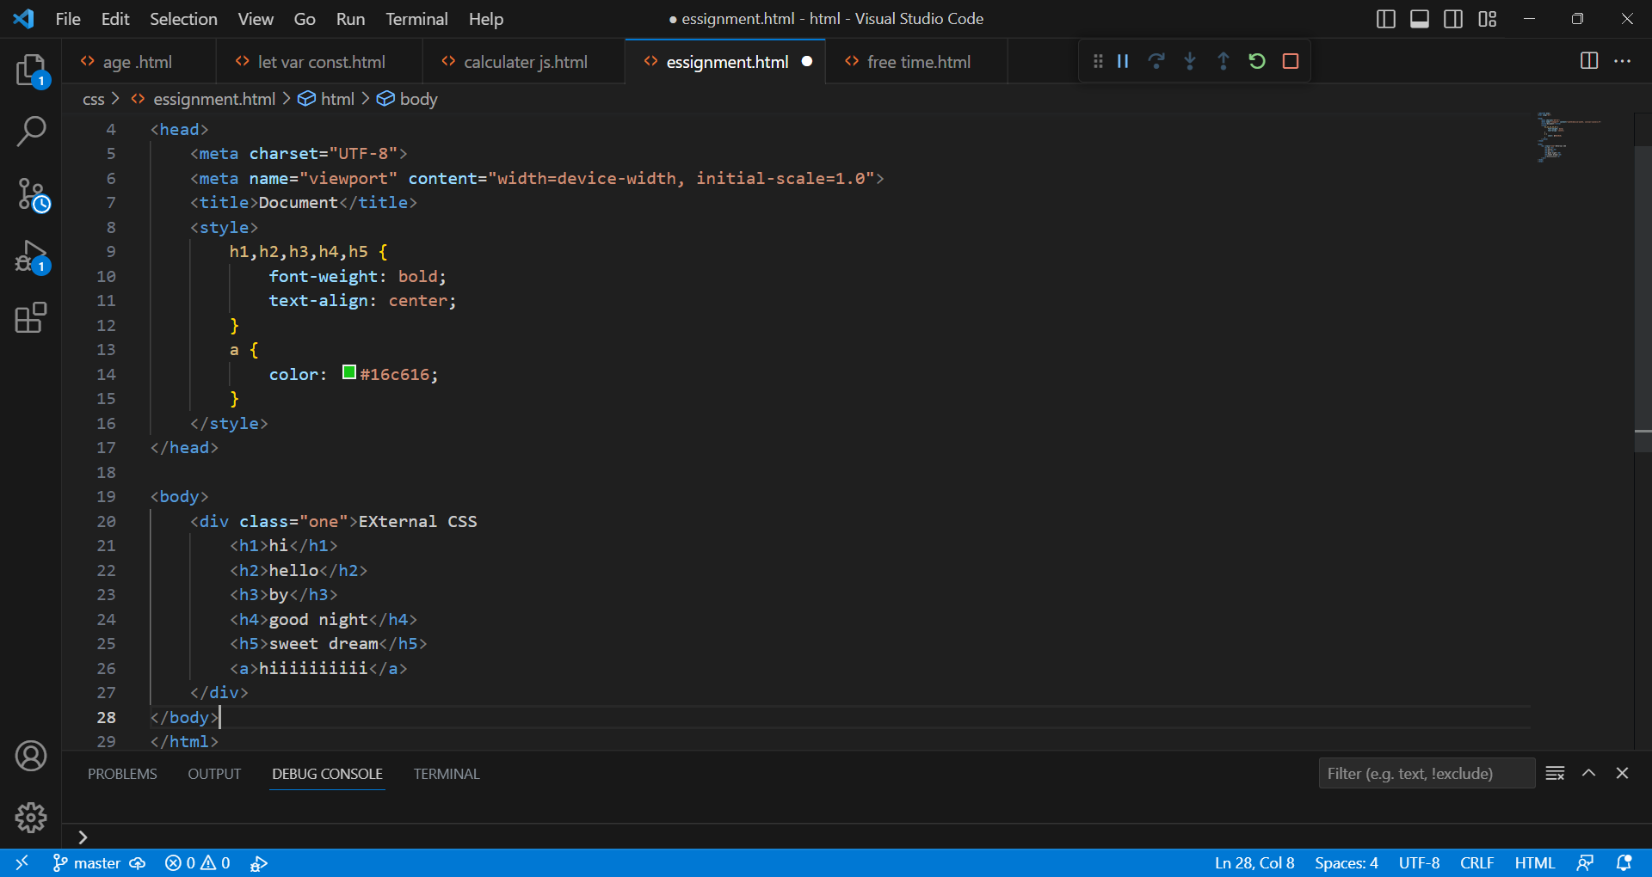

15) what are the external style sheets?

A An external style sheet is a sepsrste CSS file that can be accessed by creating a link within the head section of the webpage.

Multiple webpages can use the same link to access the stylesheet.

The link to an external style sheet is placed within the head section of the page.



16) What are the advantages and disadvantages of using external style sheet?

* Advantages
* Since the CSS code is in a separate documant, your HTML files will have a cleaner structure and are smaller in size.
* You can use the same CSS file for multiple pages.
* Disadvantages
* Your pages may not be rendered correctly until the external CSS is loaded.
* Uploading or linking to multiple CSS files can increase your site’s download time.

17) What is the meaning of the CSS selector?

A CSS selectors are used to find the HTML elements you want to style.

* Element selector
* Id selector
* Class selector
* Universal selector
* Group selector

18) What are the media types allowed by CSS?

A Media types allow you to apply different styles to different devices or media types.

* All - used for all media devices
* Print - used for printers
* Screen - used for computer screens, tablets, smart-phones ets.
* Speech - used for screen readers that “reads” the page out load

19) What is the rule set?

A CSS rule cnsists of a selector and a declaration block.

( h1 is selector )

h1{

color: red; (declaration)

text align: center; (declaration)

}

1. The selector points to the HTML element you want to style.
2. The declaration block contains one or more declarations separated by semicolons.
3. Each declaration includes a CSS property name and a value, separated by a colon.
4. Multiple CSS declarations are separated with semicolons, and declaration blocks are surrounded by curly braces.

20) create layout .

